MDC to host mentored dove hunt on Sept. 26, 2026
The Missouri Department of Conservation (MDC) and Conservation Law Enforcement at Fort Leonard Wood will be hosting a mentored dove hunt for first-time dove hunters ages 18 to 34 on Sept. 26, 2026.
This mentored dove hunt is specifically designed for ten individuals aged 18 to 34 who have never harvested a dove. Participants will learn more about dove management at Fort Leonard Wood Police Department building between 1730 - 1830 hours on September 25th. Registered dove hunt participants must attend the pre-hunt management program on September 25th to attend the mentored dove hunt on September 26th.
MDC will be providing transportation to & from private property in Phelps County on September 26th; the MDC van will leave Ft. Leonard Wood Police Station Parking Lot at 0600-hours and return from the dove hunt by 1300-hours on Saturday, September 26th.
Fort Leonard Wood Police Station: 261E W 19th, Fort Leonard Wood, MO 65473
Complete program and event details will be sent to registered participants by September 23rd. Participants will need to have their Hunter Education Certificate, Small Game Hunting Permit, and Migratory Bird Hunting Permit.
All shotguns, shotshells, earplugs, and safety glasses will be provided by MDC; if the participant chooses to bring their own 12 gauge or 20-gauge shotgun, MDC will provide the shotshells. Participant MUST have all proper firearm paperwork for transport within FLW & gate clearance IF utilizing their own shotgun for this event.
To register for this private event, paste into URL: https://mdc.mo.gov/PrivateEvents ; then enter the private workshop code: B477 Registration deadline is 1200-hours on September 23rd.
Questions about the hunt may be directed to MDC Conservation Educator and program lead Dwight Warnke at Dwight.Warnke@mdc.mo.gov.
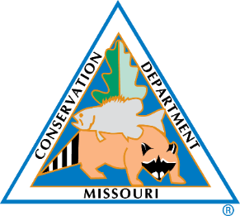
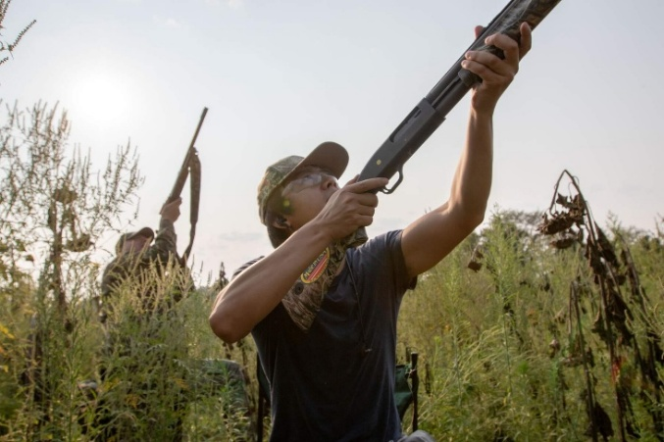

MDC will be hosting a mentored dove hunt for first-time dove hunters aged 18 to 34 on Sept. 26

